

# **Experiment : Temperature and Humidity Measurement using DHT11 and Arduino Uno**

**1. Introduction** This lab project demonstrates the use of the DHT11 sensor to measure ambient temperature and humidity and display the output on a 16x2 LCD screen using an Arduino Uno. The DHT11 sensor provides digital temperature and humidity readings, which are processed and displayed in real-time.

2. **Objective**: The objective of this experiment is to measure temperature and humidity using the DHT11 sensor, process the data with an Arduino Uno, and display the readings on a 16x2 LCD screen. This experiment aims to demonstrate the interfacing of a temperature and humidity sensor with an Arduino and effectively visualizing real-time environmental data.

**3. Components Used**

* Arduino Uno
* DHT11 Temperature and Humidity Sensor
* 16x2 LCD Display
* Potentiometer (for adjusting LCD brightness)
* Connecting Wires

**4. Implementation & Circuit Diagram: T**he DHT11 sensor has three main connections:

* VCC: Connected to 5V of the Arduino
* GND: Connected to GND of the Arduino
* DATA: Connected to Digital Pin 2 of the Arduino

The 16x2 LCD is connected to the Arduino using the following pin configuration:

* RS: Pin 0
* E: Pin 1
* D4, D5, D6, D7: Pins 8, 9, 10, 11
* VSS & RW: Connected to GND
* VDD: Connected to 5V
* V0: Connected to the middle pin of the potentiometer for contrast adjustment

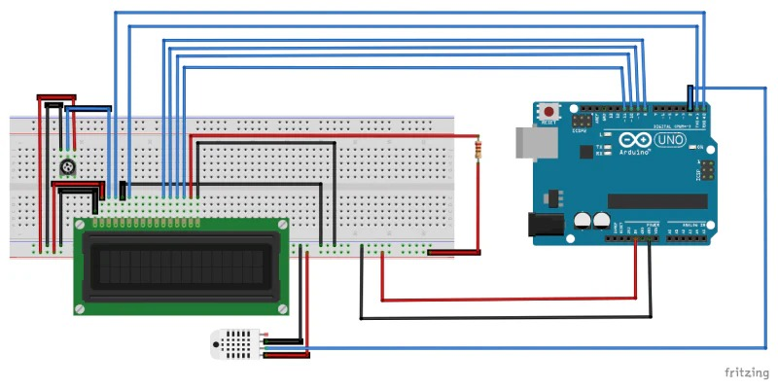

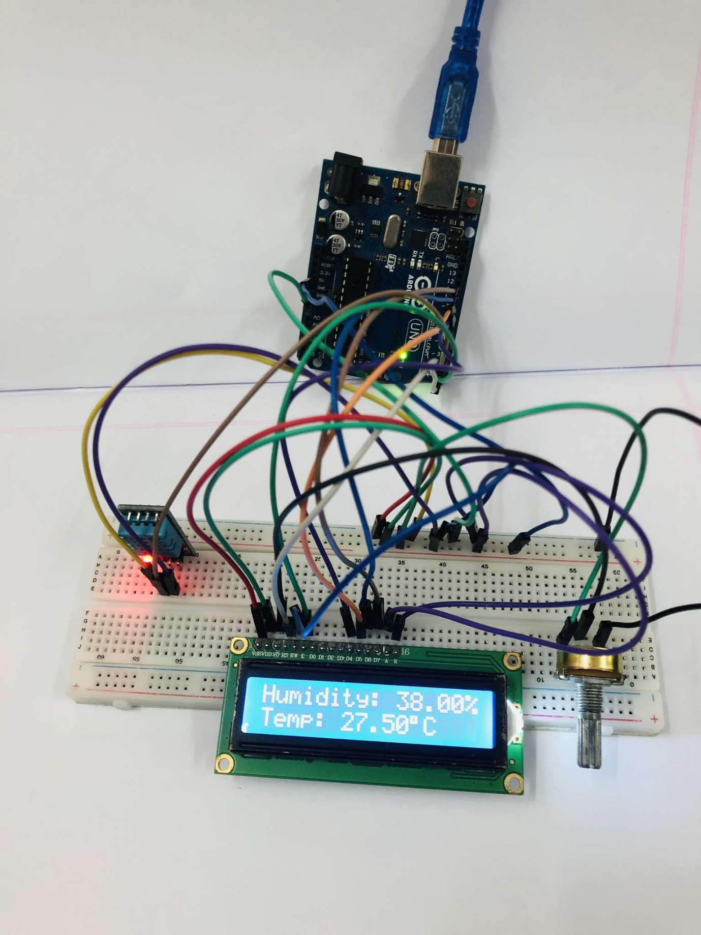

**5. Code Implementation** The following Arduino code reads the temperature from the LM35 sensor, converts the analog reading into a Celsius value, and displays it on the 16x2 LCD screen:

#include <DHT.h>

#include <LiquidCrystal.h>

LiquidCrystal lcd(0, 1, 8, 9, 10, 11);

#define DHTPIN 2

#define DHTTYPE DHT11

DHT dht(DHTPIN, DHTTYPE);

void setup() {

  lcd.begin(16, 2);

  lcd.clear();

  dht.begin();

}

void loop() {

  float humidity = dht.readHumidity();

  float temperature = dht.readTemperature();

  lcd.setCursor(0, 0);

  lcd.print("Humidity: ");

  lcd.print(humidity);

  lcd.print("%");

  lcd.setCursor(0, 1);

  lcd.print("Temp: ");

  lcd.print(temperature);

  lcd.print((char)223);

  lcd.print("C");

  delay(2000);

}

**6. Working Principle**

* The DHT11 sensor provides digital temperature and humidity readings.
* The Arduino reads the data using the dht.readHumidity() and dht.readTemperature() functions.
* The values are then displayed on the LCD screen, formatted to show percentage humidity and temperature in degrees Celsius.
* The LCD updates the values every two seconds (delay(2000)).

**7. Observations**

* The LCD correctly displays both temperature and humidity in real-time.
* The serial monitor (if used) can be used to verify readings.
* The potentiometer effectively adjusts the LCD brightness for better readability.
* The sensor provides stable and consistent readings within its accuracy range.

**8. Conclusion** This project successfully demonstrates how to use the DHT11 temperature and humidity sensor with an Arduino Uno and a 16x2 LCD display. The system efficiently reads, processes, and displays environmental data, making it useful for various applications such as weather monitoring, indoor climate control, and IoT-based smart systems.